**TASK 12: SEVEN SEGMENT DISPLAY INTERFACING.**

**PART 1. Study The Datasheet Of 74HC245 And Tell What Is the Purpose of Using It With 7 Segments Displays.**

**INTRODUCTION: -**

74HC245 is basically and 8-bit transceiver. It has 3 output states. The data can be transferred in both directions depending upon the logic level at direction control (DIR). You can enable and disable the device from the output enable (OE) pin. low power consumption, wide voltage range, low input current are the major features associated with 74HC-245. 74HC 245 is mostly used in personal computers, servers, wearable health devices, fitness devices, network switches, electronic points of sale etc.

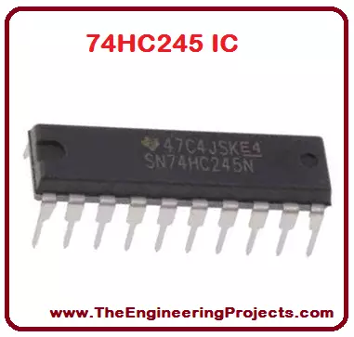

**PINES: -**

There are total twenty (20) pins in 74HC 245 having different and unique functions.

All the 20 pins are given in the table shown below.

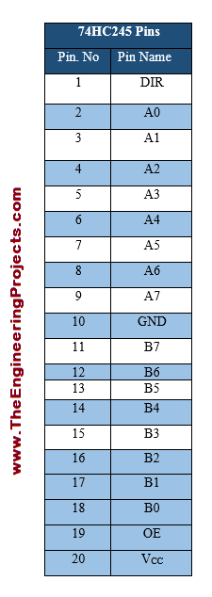 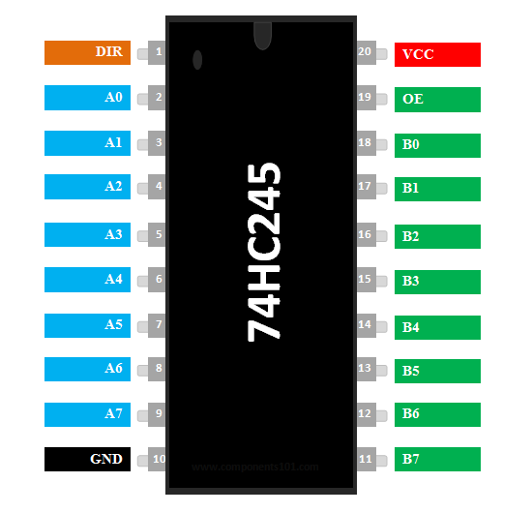

### **PIN CONFIGURATION: -**

|  |  |  |
| --- | --- | --- |
| **Pin Number** | **Pin Name** | **Description** |
| 1 | Direction Control (DIR) | This pin decides the direction of the Data. |
| 2 to 9 | Data Input/output (A0-A7) | These 8 pins can be used as 8-bit Input or 8-bit Output pins based on the state of DIR pin |
| 10 | Ground (GND) | Connected to the ground of the system |
| 11 to 18 | Data Input/output (B0-B7) | These 8 pins can be used as 8-bit Input or 8-bit Output pins based on the state of DIR pin |
| 19 | Output Enable (OE) | Active Low pin – Used to Enable/Disable Input |
| 20 | Supply Voltage (Vcc) | Differential Analog input +. Connect to ADC input |

**PINOUT: -**

With the help of pinout diagram, we can get familiar with the configuration of the pins of the particular device.

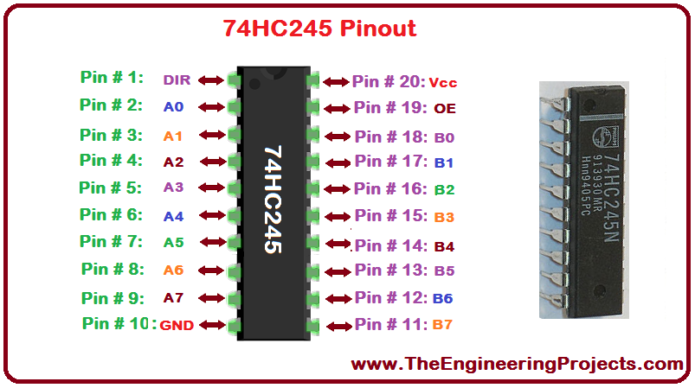

**FUNCTION DIAGRAM: -**

Functional diagram presents the internal functionality of a device.

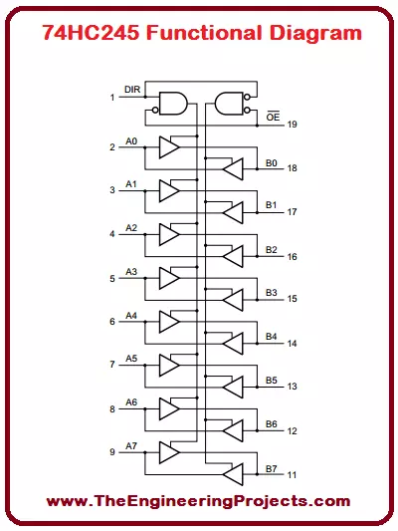

### **TRUTH TABLE: -**

The truth table showing the behavior of these inputs on outputs is given below.

[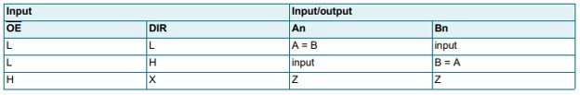](http://microcontrollerslab.com/wp-content/uploads/2020/03/74HC245-Truth-Table.jpg)

**FEATURES: -**

Some main features of this IC include:

* It is a non-inverting transceiver having 3-state outputs for connection with busses.
* This octal IC can perform bidirectional communication.
* The power supply range is 2V to 6V.
* It has a low input current of 1A.
* The propagation delay is 13 ns.
* It has high noise immunity which is a characteristic of CMOS devices.
* The quiescent current is 80 µA.
* The output current is 35mA.
* The output has the capability to drive 15 LSTTL Loads.
* Inputs include clamp diodes to protect them against static discharges.

### **APPLICATIONS: -**

* Address bus buffers
* Data bus transceivers
* Logic level converters
* Driver IC for communication protocols

🡨----------------------------------------------------------------------🡪